Summer Assignment Template

Course Title: AP Human Geography

Teacher: Cameron White

Summer Assignment Description | Students will prepare for three quizzes the first week of school:  - Map quiz over world & US  - Map quiz labelling countries in Europe, Africa, or Asia (your choice)  - Matching quiz over Unit 1 vocabulary terms  - students should also create a study sheet/flash cards for the vocabulary quiz to turn in – must be on paper – no Quizlet, etc.
Date Due | August 9-11, 2023  [Wed-Fri first week of school]
Estimated Time for Completion | ~90 minutes to create reference maps and study sheet for vocab, then study up to the day of the quiz
Tennessee Academic Standards/Approved Standards Supporting Reference (List standard(s) correlation to summer work) | Standards 1.1-12 [Unit 1 of College Board’s Curriculum Framework for AP Human Geography}
Rationale for Summer Assignment | Vocabulary terms, particularly in unit 1, are integral to understanding and succeeding in the course and on the AP exam in May. Unit one terms and map types, region types, etc., are often foundational to student success as the course proceeds. Likewise, the ability to accurately refer to various regions of the country and world AND to possess an accurate mental map is crucial to succeeding in class, particularly in writing FRQ responses as test prep and assessment.
Resources needed to complete Summer assignment | - vocabulary terms list  - lists of geographical places to know – US & world  - blank maps of Africa, Europe, and Asia – choose one to label and study!
How and when will this summer assignment be assessed and scored? Also, what grading category and what percentage will this summer assignment count in the student’s grade? | - August 9 – world & US maps quiz – in part one, a region from the list will be shaded and students need to be able to identify the region; in part two, the name of the region will be given, and students will need to be able to correctly color in or circle the region  - August 11 – students will be given a blank map of either Asia, Africa, or Europe (whichever of the three they choose) and will need to correctly label each country on the continent  - August 12 - the vocabulary quiz will be matching. 25% of the grade for the vocabulary quiz will come from students’ study sheet/flash cards, which will be taken up and graded the day of the quiz.
Additional Summer Assessments (If applicable - what grading category and what percentage will each additional summer assignment count in the student’s grade?) | - US & world map quiz – 100 point assignment grade  - continent map quiz – 100 point assignment  - Unit 1 vocab quiz – 100 point assessment grade (75% quiz, 25% study sheet/cards)
Teacher Summer Contact Information | cameron.white@acsk-12.org  Please reach out if you need me, or just to say hi!

Vocabulary 1 APHuG Unit I
- For each vocabulary term, you will use independent research (Internet) to define each term. Make sure to focus on definitions specifically related to human geography. Also, make sure you seek to understand each term instead of simply memorizing the definitions, in case my definition and your definition are not exactly the same.
- Also, for each term, you will need to be able to provide a relevant example or illustration to show that you fully understand what the term is and can apply it to geographical patterns and processes
- You may either write these out on paper however you choose, put them in some sort of chart, or create flash cards with the term on one side and the definition & example(s) on the back (recommended)
- For Unit 1 in particular, you may want to look at visual examples of some of the concepts listed (cartogram, chloropleth, longitude, etc.) and include them on your flash cards/in your study if possible

reference map
thematic map
absolute distance
relative distance
clustered spatial distribution
dispersed spatial distribution
elevation
GIS
remote sensing
census
distance decay
space-time compression
human-environment interaction
sustainability
environmental determinism
possibilism
global scale
regional scale
national scale
local scale
region
formal region
functional region
vernacular/perceptual region
cartogram (map)
choropleth (map)
dot density (map)
isoline (map)
latitude
longitude
Prime Meridian
Equator
International Date Line
scale
toponym

Example of how a study chart might look...

Term | Definition | Example/Illustration
toponym | specific place name | Arlington, Tennessee
clustered spatial distribution | when objects exist in close proximity to one another

World Stuff to Know  (some of these will overlap – some places will fit into more than one region – borders are imprecise and not exact – all of that is fine!) | US Stuff to Know  (some of these will overlap – some places will fit into more than one region – borders are imprecise and not exact – all of that is fine!)
- 4/5 oceans (Atlantic, Pacific, Artic, Indian, some maps will list a Southern Ocean)  - 7 continents (Asia, Africa, Europe, North America, South America, Antarctica, Australia)  Regions  - Latin America  - North Africa  - Sahara Desert  - sub-Saharan Africa  - Middle East  - Oceania  - Southeast Asia  - Central Asia  - Indian subcontinent  - Balkans  - Baltics  - Horn of Africa  - British Isles  - Scandinavia  - Asia Minor  Landforms  - Himalayas (mountains)  - Alps (mountains)  - Andes (mountains)  - Urals (mountains)  - Pyrenees (mountains)  Rivers/Lakes/Seas  - Congo River  - Nile River  - Ganges River  - Yellow River  - Yangtze River  - Amazon River  - Caribbean Sea  - South China Sea  - Ural Sea  - Caspian Sea  - Mediterranean Sea  - Adriatic Sea  - Red Sea | Regions  New England  Pacific Northwest  Midwest  Great Plains  Bible Belt  Sun Belt  Rust Belt  “The South”  West Coast  Southwest  Gulf Coast  Atlantic seaboard  Landforms  - Rockies (mountains)  - Appalachians (mountains)  - Sierra Nevadas (mountains)  Rivers/Lakes/Seas  - Great Lakes (not individually, just where the five of them are)  - Mississippi River  - Rio Grande River  - Ohio River  - Great Salt Lake  - Lake Ponchartrain  - Gulf of Mexico

Africa – blank map for quiz
if you choose to label countries of Africa on the quiz, this is the map you will be given to label

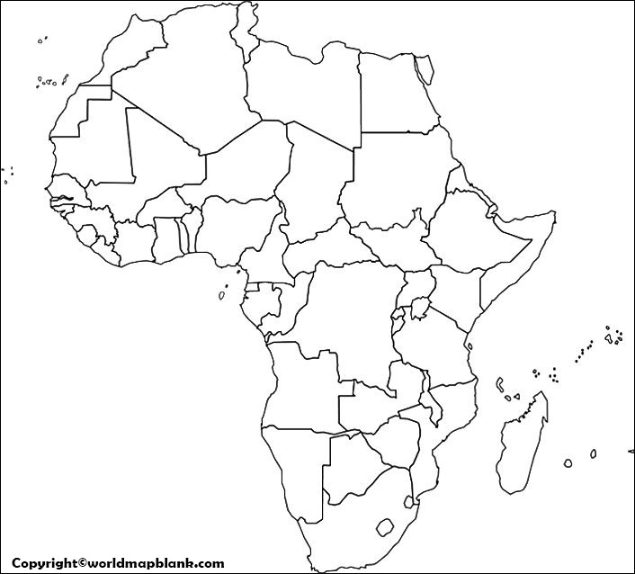

Asia – blank map for quiz
if you choose to label countries of South America on the quiz, this is the map you will be given to label

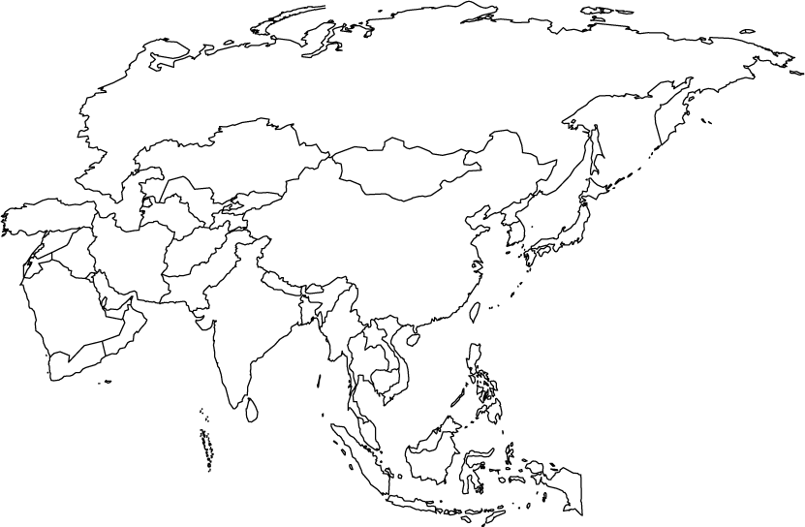

Europe – blank map for quiz
if you choose to label countries of Europe on the quiz, this is the map you will be given to label

